Testing Vehicle

Complete startup procedures - minus starting the engine. All processes should be running and visualization plots should be running.

Step 1 - Get the left, right and center settings

The goal of this test is to adjust the steering PID and confirm steering control without forward motion.

* Disconnect power to the steering motor;
* # to adjust steering settings (i.e. rosparam set /steering "[{hard left}, {hard right}, {center}, {motor steer_effort}, {PID Ki}]")
* Turn it all the way to the left; Make note of the reported angle

|  | 22826 |
| --- | --- |

* Turn it all the way to the right; Make note of the reported angle

|  | 45592 |
| --- | --- |

* Align it in the center; Make note of the angle.

|  | 33060 |
| --- | --- |

* Put these numbers in the params setting.

Use $ rosparam set /steering "[22826.0, 45592.0, 33060.0, 60.0, 3.0]"

Open FileZilla and update /home/ubuntu/catkin_ws/src/teensy_launch.launch param settings to match

Reconnect power to steering motor

Step 2 - Check the steering motor power and PID settings

Note in the plot window the front_angle_target and front_angle_klm is where it was just set.

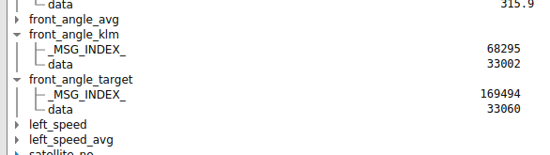

Test 1: - single statement

| $ timeout 8 rostopic pub -r 10 teleop/cmd_vel geometry_msgs/Twist '{linear: {x: 0.0, y: 0.0, z: 0.0}, angular: {x: 0.0,y: 0.0,z: 0.3}}' |
| --- |
|  |
| $ rosparam set /steering "[22826.0, 45592.0, 33060.0, 60.0, 2.0]"  $ timeout 8 rostopic pub -r 10 teleop/cmd_vel geometry_msgs/Twist '{linear: {x: 0.0, y: 0.0, z: 0.0}, angular: {x: 0.0,y: 0.0,z: 0.3}}' |
|  |

Test 2: - two statements

PuTTy into RPi, $ bash steer2.sh

| #!/bin/bash  #steer2  timeout 8 rostopic pub -r 10 teleop/cmd_vel geometry_msgs/Twist '{linear: {x: 0.0, y: 0.0, z: 0.0}, angular: {x: 0.0,y: 0.0,z: 0.3}}'  timeout 8 rostopic pub -r 10 teleop/cmd_vel geometry_msgs/Twist '{linear: {x: 0.0, y: 0.0, z: 0.0}, angular: {x: 0.0,y: 0.0,z: -0.3}}'  timeout 12 rostopic pub -r 10 teleop/cmd_vel geometry_msgs/Twist '{linear: {x: 0.0, y: 0.0, z: 0.0}, angular: {x: 0.0,y: 0.0,z: 0.6}}'  timeout 12 rostopic pub -r 10 teleop/cmd_vel geometry_msgs/Twist '{linear: {x: 0.0, y: 0.0, z: 0.0}, angular: {x: 0.0,y: 0.0,z: -0.6}}' |
| --- |
|  |

Test 3: - three statements

PuTTy into RPi, $ bash steer3.sh

| #!/bin/bash  #steer3.sh  timeout 8 rostopic pub -r 10 teleop/cmd_vel geometry_msgs/Twist '{linear: {x: 0.0, y: 0.0, z: 0.0}, angular: {x: 0.0,y: 0.0,z: 0.3}}'  timeout 8 rostopic pub -r 10 teleop/cmd_vel geometry_msgs/Twist '{linear: {x: 0.0, y: 0.0, z: 0.0}, angular: {x: 0.0,y: 0.0,z: -0.3}}'  timeout 12 rostopic pub -r 10 teleop/cmd_vel geometry_msgs/Twist '{linear: {x: 0.0, y: 0.0, z: 0.0}, angular: {x: 0.0,y: 0.0,z: 0.6}}'  timeout 12 rostopic pub -r 10 teleop/cmd_vel geometry_msgs/Twist '{linear: {x: 0.0, y: 0.0, z: 0.0}, angular: {x: 0.0,y: 0.0,z: -0.6}}'  timeout 15 rostopic pub -r 10 teleop/cmd_vel geometry_msgs/Twist '{linear: {x: 0.0, y: 0.0, z: 0.0}, angular: {x: 0.0,y: 0.0,z: 1.0}}'  timeout 15 rostopic pub -r 10 teleop/cmd_vel geometry_msgs/Twist '{linear: {x: 0.0, y: 0.0, z: 0.0}, angular: {x: 0.0,y: 0.0,z: -1.0}}' |
| --- |
| Looks like it missed getting down to 22K |
| Can’t get there even with more time at power of 60 and Ki of 2  Lets see what the info sentences say    This btw, killed ROS |

1:30pm 4/4/2020 - see saved picture - I have disconnected everything except the front angle sensor. I am still getting this periodic noise.

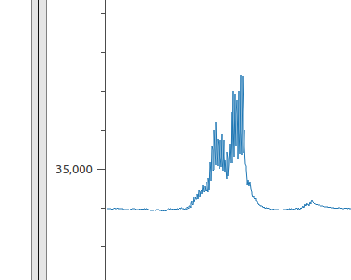

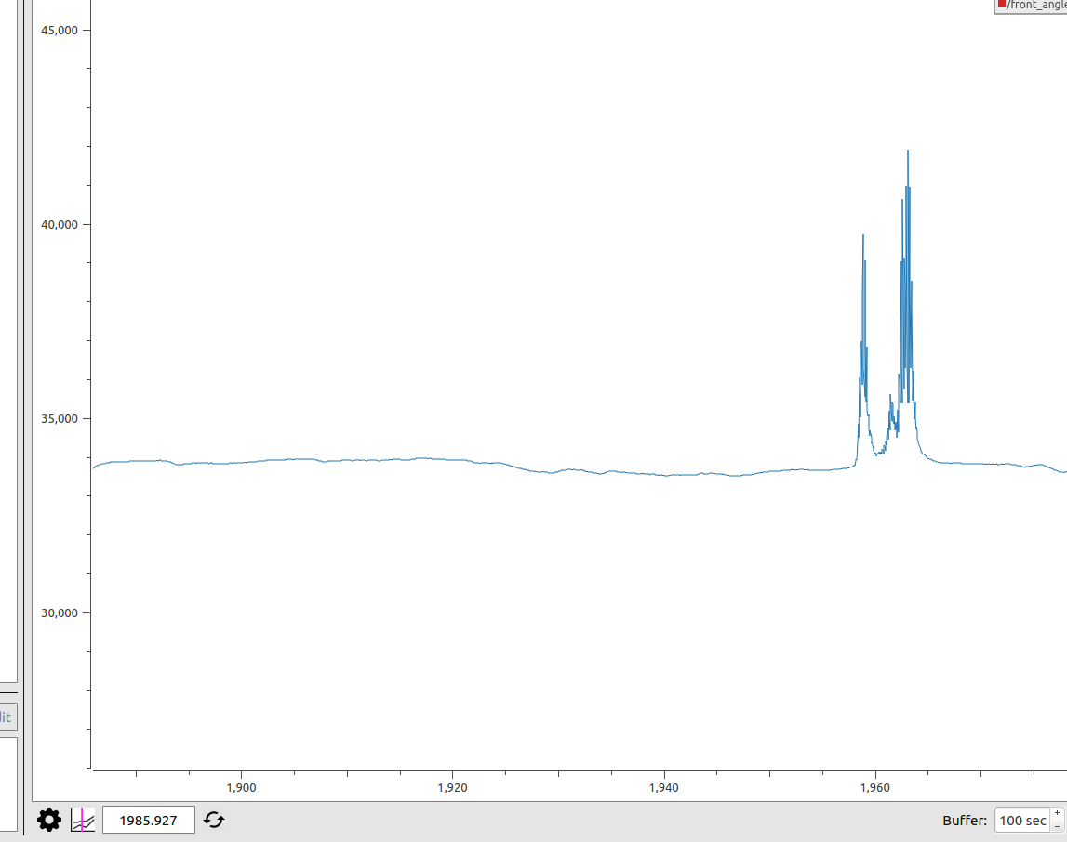

It is happening about every 90 seconds with the motor controller USB port powered on.

I believe the issue is with the motor controller board; If I disconnect the power, signal, gnd line I no longer get this spike. I am going to continue testing.

Back to the goal, get a good 3 position test for the Ki and steering motor power setting

$ rosparam get /steering

[22826.0, 45592.0, 33060.0, 60.0, 3.0]

Test 3: - three statements

PuTTy into RPi, $ bash steer3.sh

| This is a mess. Partially due to the noise. Trying again. |
| --- |
| Without the noise the performance was better, but still was not going to reach the goal. Increasing power to 65. |
| $ rosparam set /steering "[22826.0, 45592.0, 33060.0, 65.0, 3.0]" |
| Rerunning bash  Goofiness with the noise….. |
|  |
| $ rosparam set /steering "[22826.0, 45592.0, 33060.0, 70.0, 3.0]"  $ rosparam set /steering "[24300.0, 44000.0, 33060.0, 70.0, 3.0]" |
| Winner! |

Now onto steering straight!

We want to go straight and see if the heading varies, adjust center position until it maintains heading, basically.

Test 4: - Steer straight -

Check the safety of the tractor

Confirm emergency shutoff devices

Engage the transmission

Start with 0.5 m/s

| $ bash steer_straight1.sh  #!/bin/bash  timeout 12 rostopic pub -r 10 teleop/cmd_vel geometry_msgs/Twist '{linear: {x: 0.5, y: 0.0, z: 0.0}, angular: {x: 0.0,y: 0.0,z: 0.0}}' |
| --- |
| The speed set param:  $ rosparam set /speed "[1000, 1290, 1500, 125, -100, 70, 5, 0, 20]"  $ rosparam get /speed  [1000.0, 1290.0, 1500.0, 125.0, -100.0, 70.0, 5.0, 0.0, 20.0]  Adjusting top speed:  $ rosparam set /speed "[1000, 1290, 1600, 125, -100, 70, 5, 0, 20]" |
| My tractor is pulling to the left; I need to increase my center value  $ rosparam set /steering "[24300.0, 44000.0, 33500.0, 70.0, 3.0]" |
| That looks pretty straight! |

| #!/bin/bash  timeout 30 rostopic pub -r 10 teleop/cmd_vel geometry_msgs/Twist '{linear: {x: 0.5, y: 0.0, z: 0.0}, angular: {x: 0.0,y: 0.0,z: 0.0}}' |
| --- |
|  |
| Increasing top PWM setting  $ rosparam set /speed "[1000, 1290, 1700, 125, -100, 70, 5, 0, 20]" |
|  |
| $ rosparam set /steering "[24300.0, 44000.0, 34000.0, 70.0, 3.0]"  $ rosparam set /speed "[1000, 1290, 1800, 125, -100, 70, 5, 0, 20]" |
|  |
|  |
| It is time to monitor the transmission PWM and see how high it is going and if it is reaching the max and coming back down. Take a screen print of the PWM with the tractor not even running and there is no chance for it to achieve the target speed.  Open FileZilla and update /home/ubuntu/catkin_ws/src/teensy_launch.launch param settings to match  $ rosparam set /steering "[24300.0, 44000.0, 34000.0, 70.0, 3.0]"  $ rosparam set /speed "[1000, 1290, 1800, 125, -100, 70, 5, 0, 20]"  UPDATED:  <rosparam param="steering">[24300.0, 44000.0, 34000.0, 70.0, 3.0]</rosparam>  <rosparam param="speed">[1000.0, 1290.0, 1800.0, 125.0, -100.0, 70.0, 5.0, 0.0, 20.0]</rosparam> |

Test 4: - Steer straight - Not running - check PWM

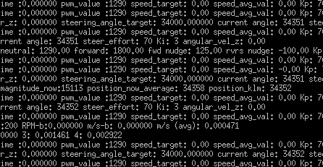

$ bash steer_straight1.sh

| $ bash steer_straight1.sh |
| --- |
| timeout 30 rostopic pub -r 10 teleop/cmd_vel geometry_msgs/Twist '{linear: {x: 0.5, y: 0.0, z: 0.0}, angular: {x: 0.0,y: 0.0,z: 0.0}}' |
| [INFO] [1586097131.195414]: speed_control - time_delta :0.000000 prev_cmd_vel_time :13355505.000000 pwm_value :1451 speed_target: 0.50 speed_avg_val: 0.00 Kp: 70.00 Ki: 5.00 start_forward_nudge 125.00  [INFO] [1586097132.195767]: speed_control - time_delta :0.000000 prev_cmd_vel_time :13356505.000000 pwm_value :1476 speed_target: 0.50 speed_avg_val: 0.00 Kp: 70.00 Ki: 5.00 start_forward_nudge 125.00  [INFO] [1586097133.196468]: speed_control - time_delta :0.000000 prev_cmd_vel_time :13357504.000000 pwm_value :1501 speed_target: 0.50 speed_avg_val: 0.00 Kp: 70.00 Ki: 5.00 start_forward_nudge 125.00  [INFO] [1586097134.198095]: speed_control - time_delta :0.000000 prev_cmd_vel_time :13358505.000000 pwm_value :1473 speed_target: 0.50 speed_avg_val: 0.00 Kp: 70.00 Ki: 5.00 start_forward_nudge 125.00  [INFO] [1586097135.198277]: speed_control - time_delta :0.000000 prev_cmd_vel_time :13359505.000000 pwm_value :1498 speed_target: 0.50 speed_avg_val: 0.00 Kp: 70.00 Ki: 5.00 start_forward_nudge 125.00  [INFO] [1586097136.198669]: speed_control - time_delta :0.000000 prev_cmd_vel_time :13360505.000000 pwm_value :1471 speed_target: 0.50 speed_avg_val: 0.00 Kp: 70.00 Ki: 5.00 start_forward_nudge 125.00  [INFO] [1586097136.836944]: chkrpm 10 sec. - revolutions :0.000000 num_readings:200 RPM-b:0.000000 m/s-b: 0.000000 m/s (avg): 0.001640  [INFO] [1586097136.841104]: readings[readIndex] - 0 :0.003409 1:0.001461 2:0.000487 3: 0.000487 4: 0.002922  [INFO] [1586097137.199078]: speed_control - time_delta :0.000000 prev_cmd_vel_time :13361505.000000 pwm_value :1496 speed_target: 0.50 speed_avg_val: 0.00 Kp: 70.00 Ki: 5.00 start_forward_nudge 125.00  [INFO] [1586097138.201044]: speed_control - time_delta :0.000000 prev_cmd_vel_time :13362506.000000 pwm_value :1468 speed_target: 0.50 speed_avg_val: 0.00 Kp: 70.00 Ki: 5.00 start_forward_nudge 125.00  [INFO] [1586097139.201357]: speed_control - time_delta :0.000000 prev_cmd_vel_time :13363504.000000 pwm_value :1493 speed_target: 0.50 speed_avg_val: 0.00 Kp: 70.00 Ki: 5.00 start_forward_nudge 125.00  [INFO] [1586097140.201645]: speed control - param retrieval - reverse :1000.00 neutral: 1290.00 forward: 1800.00 fwd nudge: 125.00 rvrs nudge: -100.00 Kp: 70.00 Ki: 5.00 Kd: 0.00 timeout: 20.00  [INFO] [1586097140.208449]: speed_control - time_delta :0.000000 prev_cmd_vel_time :13364505.000000 pwm_value :1466 speed_target: 0.50 speed_avg_val: 0.00 Kp: 70.00 Ki: 5.00 start_forward_nudge 125.00  [INFO] [1586097141.206394]: speed_control - time_delta :0.000000 prev_cmd_vel_time :13365504.000000 pwm_value :1491 speed_target: 0.50 speed_avg_val: 0.00 Kp: 70.00 Ki: 5.00 start_forward_nudge 125.00  [INFO] [1586097142.207991]: speed_control - time_delta :0.000000 prev_cmd_vel_time :13366505.000000 pwm_value :1464 speed_target: 0.50 speed_avg_val: -0.00 Kp: 70.00 Ki: 5.00 start_forward_nudge 125.00  [INFO] [1586097143.209652]: speed_control - time_delta :0.000000 prev_cmd_vel_time :13367505.000000 pwm_value :1489 speed_target: 0.50 speed_avg_val: 0.00 Kp: 70.00 Ki: 5.00 start_forward_nudge 125.00  [INFO] [1586097144.210078]: speed_control - time_delta :0.000000 prev_cmd_vel_time :13368505.000000 pwm_value :1462 speed_target: 0.50 speed_avg_val: -0.00 Kp: 70.00 Ki: 5.00 start_forward_nudge 125.00  [INFO] [1586097145.210368]: speed_control - time_delta :0.000000 prev_cmd_vel_time :13369504.000000 pwm_value :1487 speed_target: 0.50 speed_avg_val: -0.00 Kp: 70.00 Ki: 5.00 start_forward_nudge 125.00  [INFO] [1586097146.210949]: speed_control - time_delta :0.000000 prev_cmd_vel_time :13370504.000000 pwm_value :1458 speed_target: 0.50 speed_avg_val: 0.00 Kp: 70.00 Ki: 5.00 start_forward_nudge 125.00  [INFO] [1586097146.835563]: chkrpm 10 sec. - revolutions :0.007843 num_readings:200 RPM-b:0.047058 m/s-b: 0.001252 m/s (avg): 0.001056  [INFO] [1586097146.839670]: readings[readIndex] - 0 :0.002435 1:0.000487 2:0.000974 3: 0.002922 4: 0.001461  [INFO] [1586097147.211277]: speed_control - time_delta :0.000000 prev_cmd_vel_time :13371504.000000 pwm_value :1483 speed_target: 0.50 speed_avg_val: 0.00 Kp: 70.00 Ki: 5.00 start_forward_nudge 125.00  [INFO] [1586097148.211743]: speed_control - time_delta :0.000000 prev_cmd_vel_time :13372505.000000 pwm_value :1456 speed_target: 0.50 speed_avg_val: 0.00 Kp: 70.00 Ki: 5.00 start_forward_nudge 125.00  [INFO] [1586097149.212036]: speed_control - time_delta :0.000000 prev_cmd_vel_time :13372705.000000 pwm_value :1290 speed_target: 0.00 speed_avg_val: 0.00 Kp: 70.00 Ki: 5.00 start_forward_nudge 125.00  [INFO] [1586097150.213652]: speed_control - time_delta :0.000000 prev_cmd_vel_time :13372705.000000 pwm_value :1290 speed_target: 0.00 speed_avg_val: 0.00 Kp: 70.00 Ki: 5.00 start_forward_nudge 125.00 |
|  |
| Raise the Ki and see what we get? |
| $ rosparam set /speed "[1000.0, 1290.0, 1800.0, 125.0, -100.0, 70.0, 6.0, 0.0, 20.0]"  {make sure to use float otherwise you will get an error} |
| $ rosparam get /speed |
| [1000.0, 1290.0, 1800.0, 200.0, -100.0, 70.0, 5.0, 0.0, 20.0] |
| I tried a few settings and I think I will go down the path of raising the nudge factor first. |
| Problem:  Speed is too fast. PID does not seem to be slowing it down. Reducing the nudge to 180 and the top speed setting to 1700  $ rosparam set /speed "[1000.0, 1290.0, 1700.0, 180.0, -100.0, 70.0, 5.0, 0.0, 20.0]" |
| Top PWM was 1500 |
| $ rosparam set /speed "[1000.0, 1290.0, 1600.0, 160.0, -100.0, 70.0, 5.0, 0.0, 20.0]" |
|  |
|  |
| $ rosparam set /speed "[1000.0, 1290.0, 1600.0, 135.0, -100.0, 70.0, 5.0, 0.0, 20.0]" |
|  |

Future tests Milestone 1 - complete a square

1. Steer steering - part 1; Run a straight then left or right turn
2. Steer steering - part 2; Run a straight then left; Then straight; Then right
3. Steer steering - part 3; Run a straight then left; Then straight; Then right; Then straight; Then left (should have completed the square)